**Python Developer for AI**

**AIP**

**\*\*\***

**LAB 00 - Python Setup Environment**

1. **Scope of Knowledges:**

- Setup Programming Environment

1. Google Colab
2. Anaconda
3. **Materials/ Softwares/ Tools:**

* Google Colab
* Anaconda

1. **Exercise:** Students need to complete the exercises below.

* **Exercise 1: Setup Colab Enviroment for Python Programming**

Step 1: Login by your gmail and go to Drive

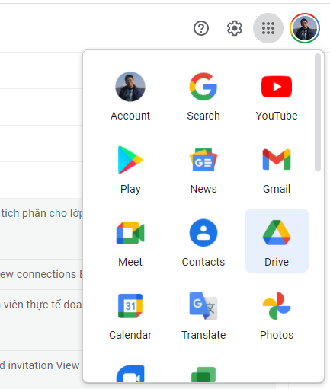

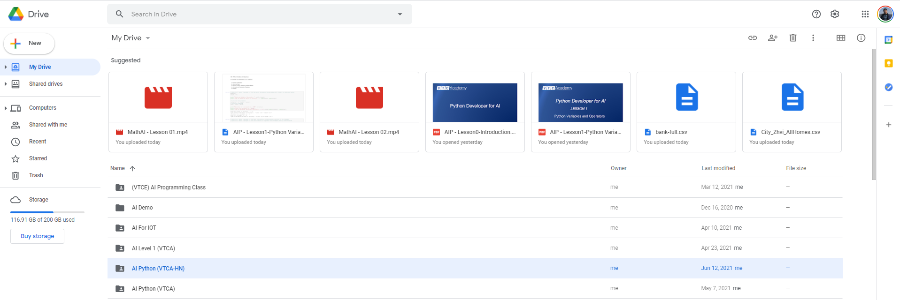

Step 2: Create a Folder and Go to that Folder

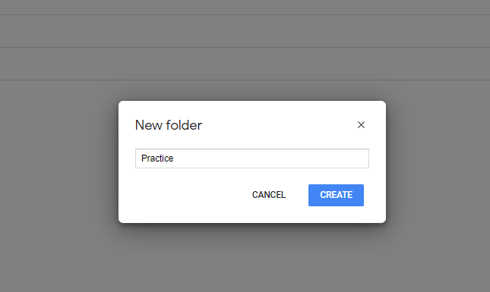

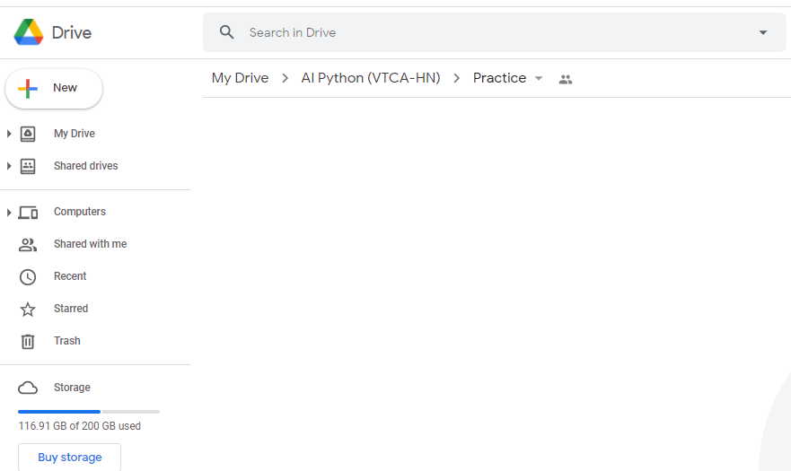

Step 3: Right Mouse and Choose Connect More App. Search for Colaboratory and click “Connect” or “Install” (This is just for the first time, your gmail does not have connect to Colab)

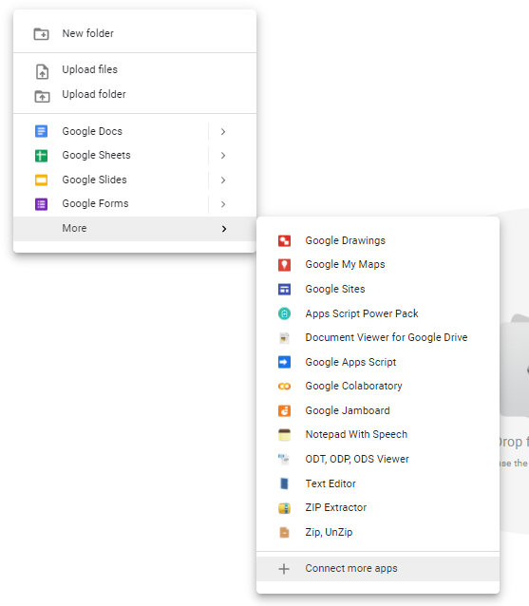

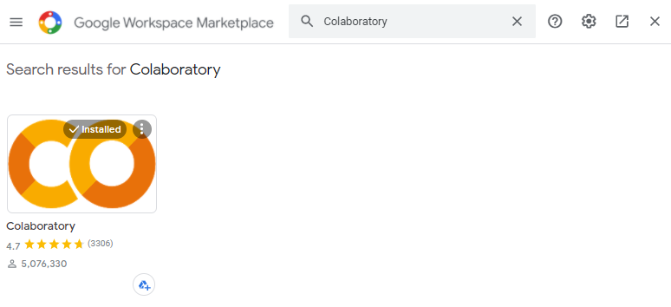

Step 4: Make sure you already connect to Colab. And now you can create a Colaboratory file. It will automatically go to the Colab Enviroment.

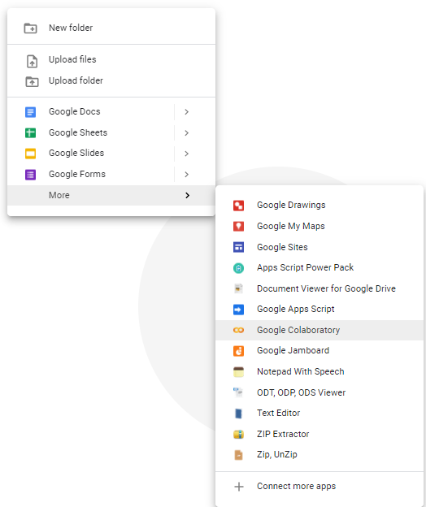

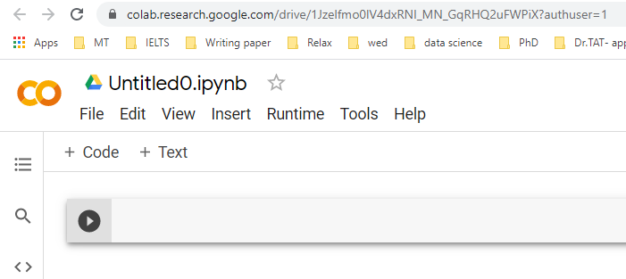

Step 5: Change the name of file from “Untitled0.ipynb” to “Lesson01-Basics.ipynb”. And run the simple code by click on .

# Comment: Sample Code

x = 10

welcome = "Hello Python"

print(welcome)

print("Wish you get the good mark ", x)

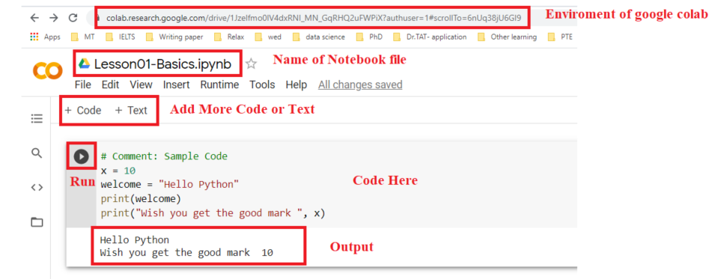

Step 6: Connect to Drive to get data. Example we have 3 files in folder “Stock Market Problem” in the Path MyDrive//AI Python (VTCA-HN)//Practice

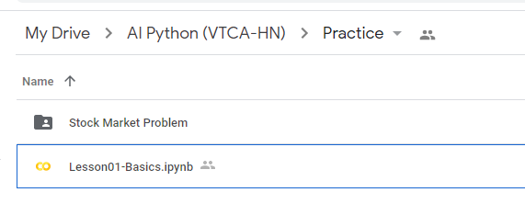

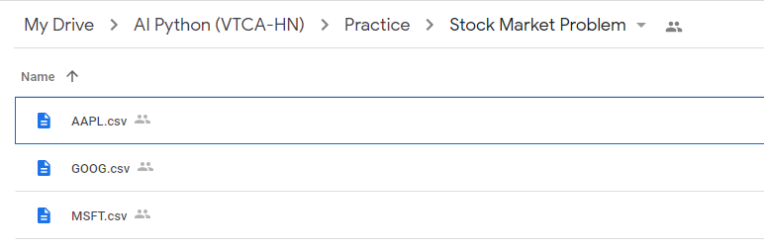

Copy code below and run:

# Mount drive

from google.colab import drive

drive.mount('/content/gdrive')

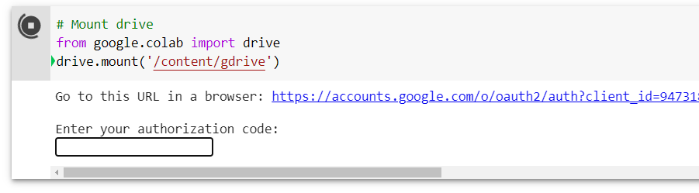

Click the link “Go to this URL in the browser”. And then choose correct drive gmail

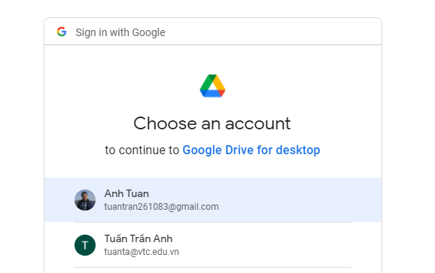

Copy the code and parse in the box

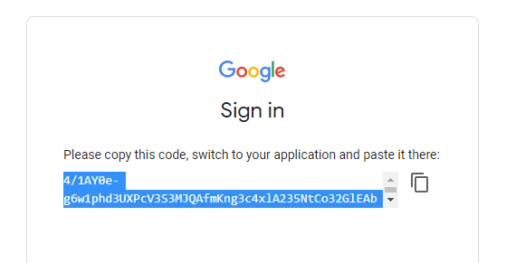

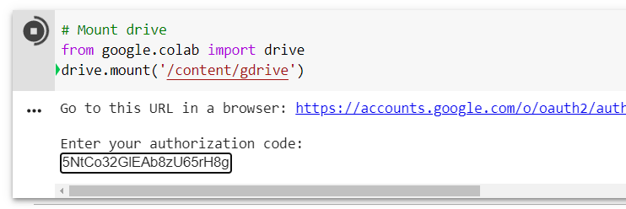

After Enter, if you see the notification “Mounted at /content.grive” means you already connect colab to your drive.

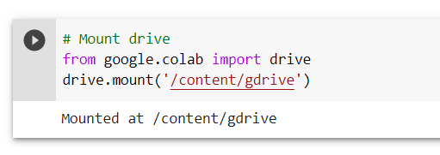

Step 7: Run Code to check Path and File.

# Check the path and file before reading them

import os

path_Data = "//content//gdrive//MyDrive//AI Python (VTCA-HN)//Practice//Stock Market Problem//"

checkPath = os.path.isdir(path_Data)

print("The path is valid or not :", checkPath)

checkFileApple = os.path.isfile(path_Data + "AAPL.csv")

checkFileGoogle = os.path.isfile(path_Data + "GOOG.csv")

checkFileMicrosoft = os.path.isfile(path_Data + "MSFT.csv")

print("The file is valid or not :", checkFileApple, checkFileGoogle, checkFileMicrosoft)

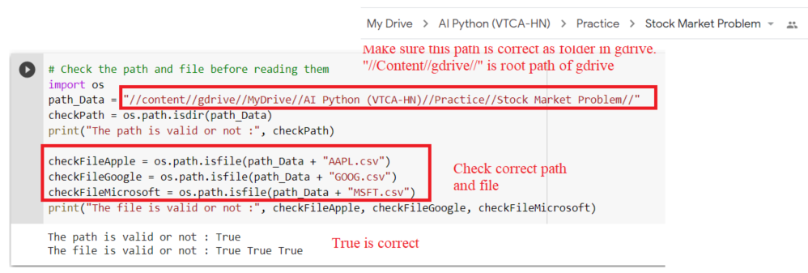

* **Exercise 2: Setup Anaconda Enviroment for Python Programming**

Step 1: Go to link “https://www.anaconda.com/products/individual#windows”. Choose correct your OS System. Mostly Window we choose “64-bit Graphical Installer (477 MB)”

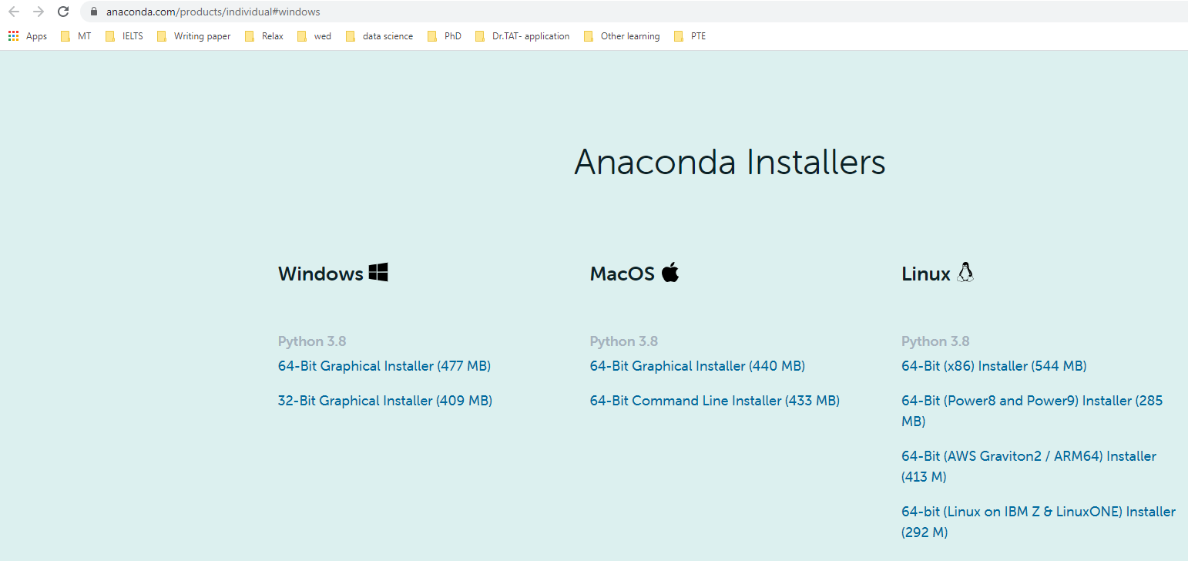

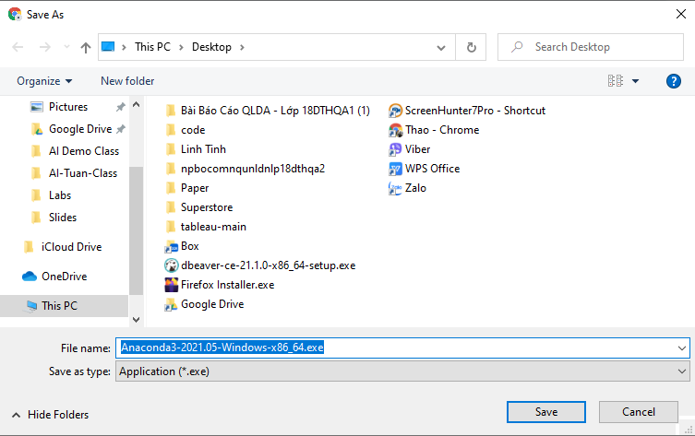

Step 2: Install Anaconda as a normal software.

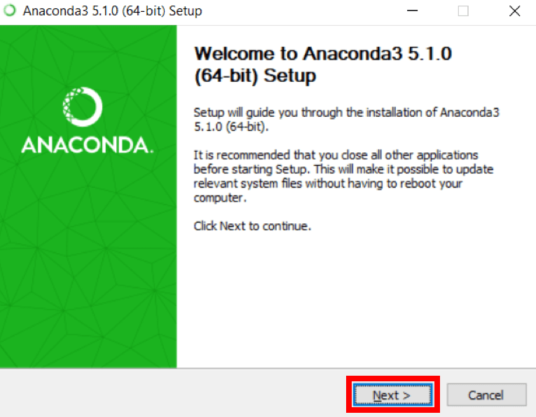

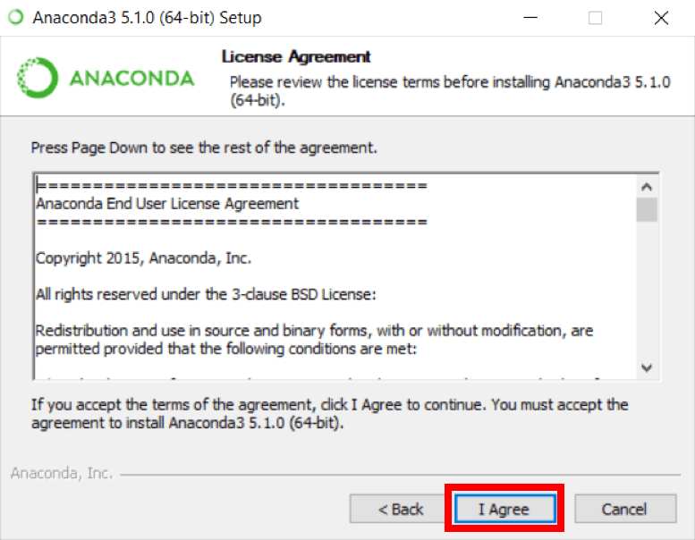

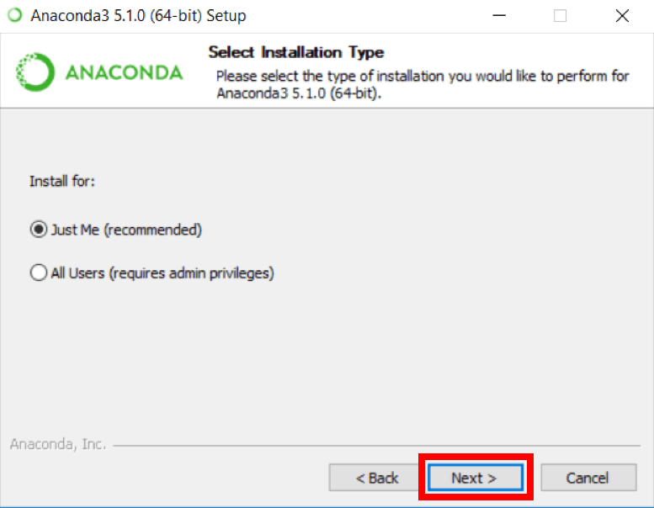

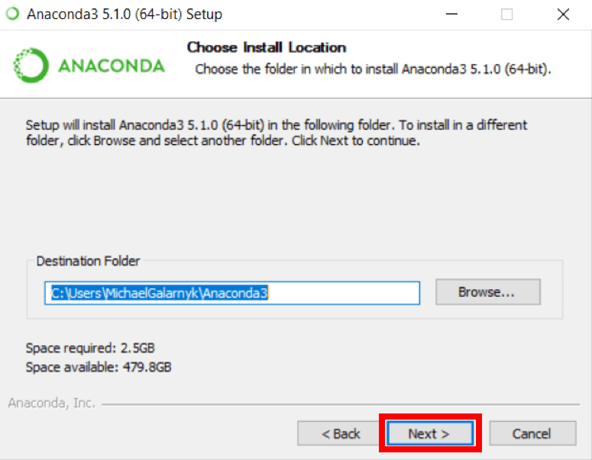

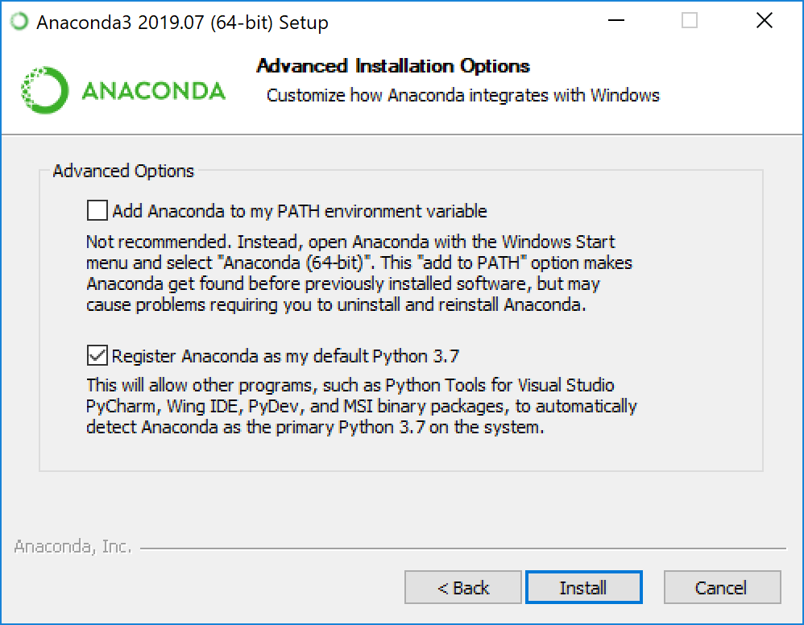

Step 3: After Finish Installation. Click Window and Type Anaconda Navigator

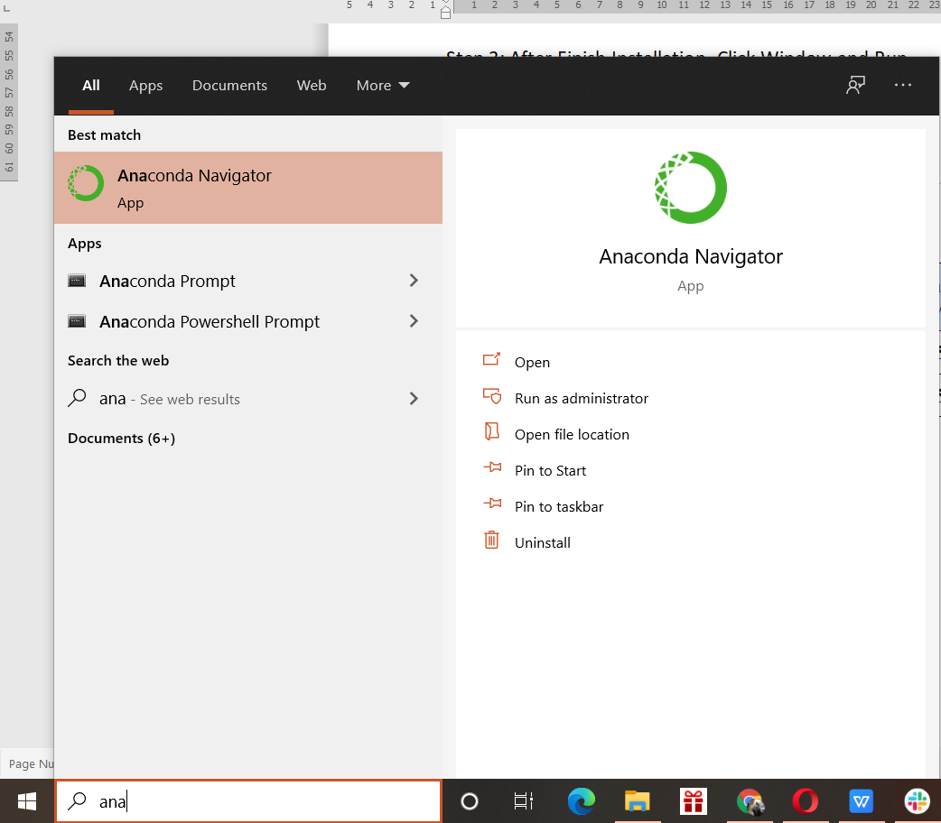

Step 4: Look up JupiterLab and click install. After that, click Launch to go to Jupiter Lab

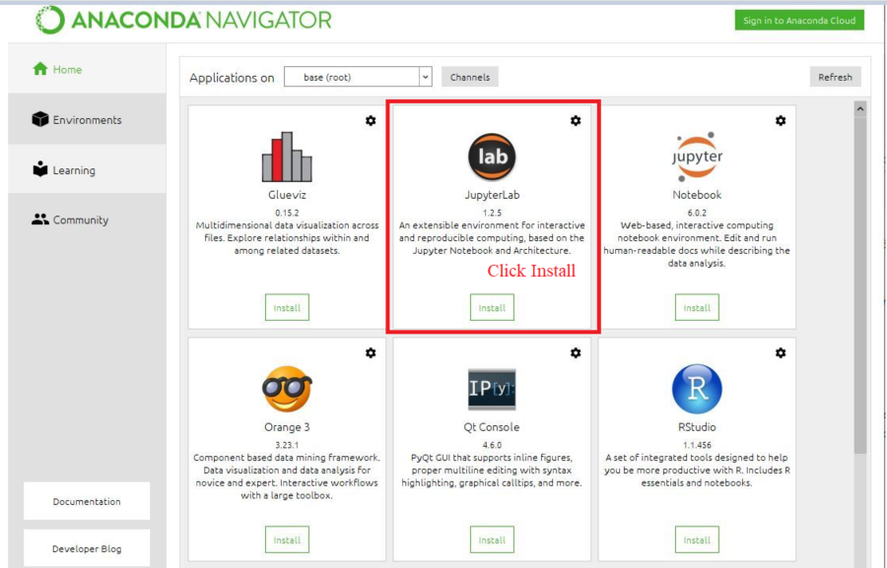

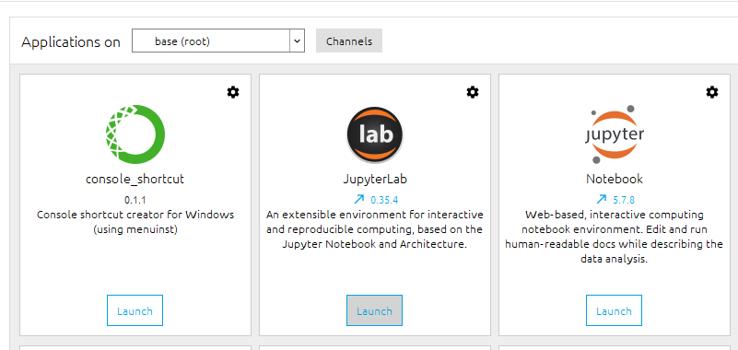

Click Icon to create new Folder. Rename this folder to “AI Python (VTCA-HN)” and go to that folder.

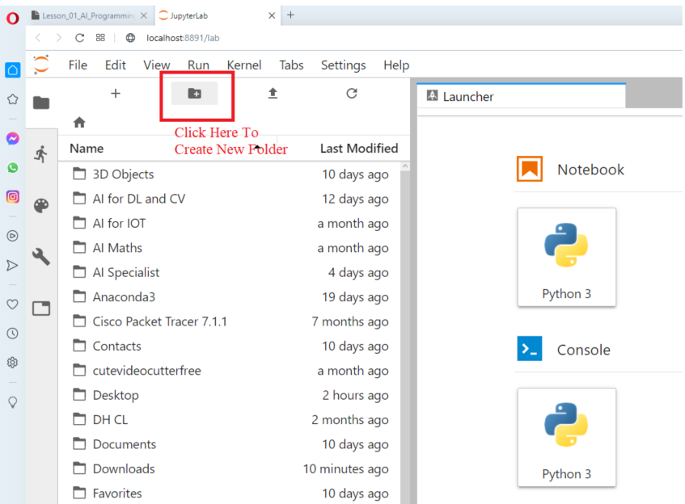

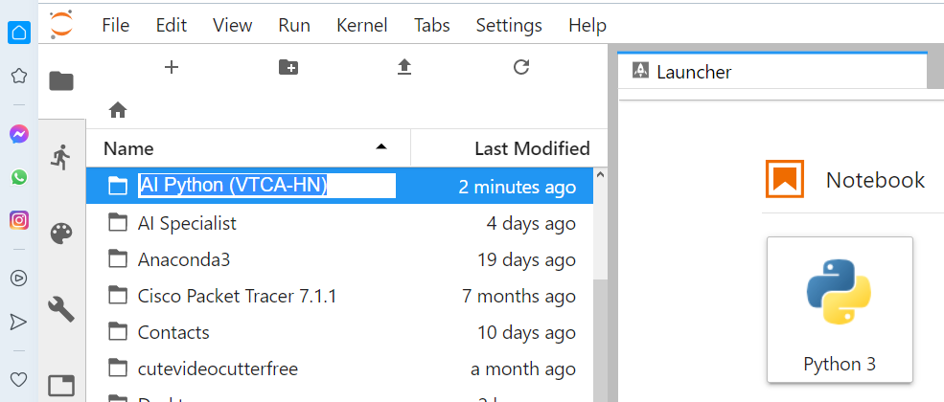

Click Create new Notebook

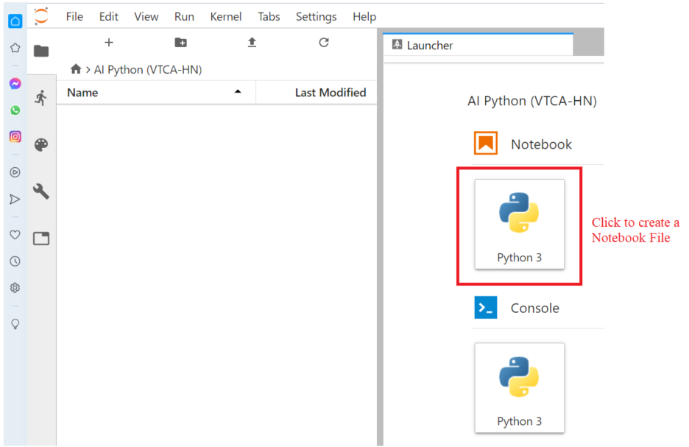

Rename this notebook to “Lesson01-Basics”

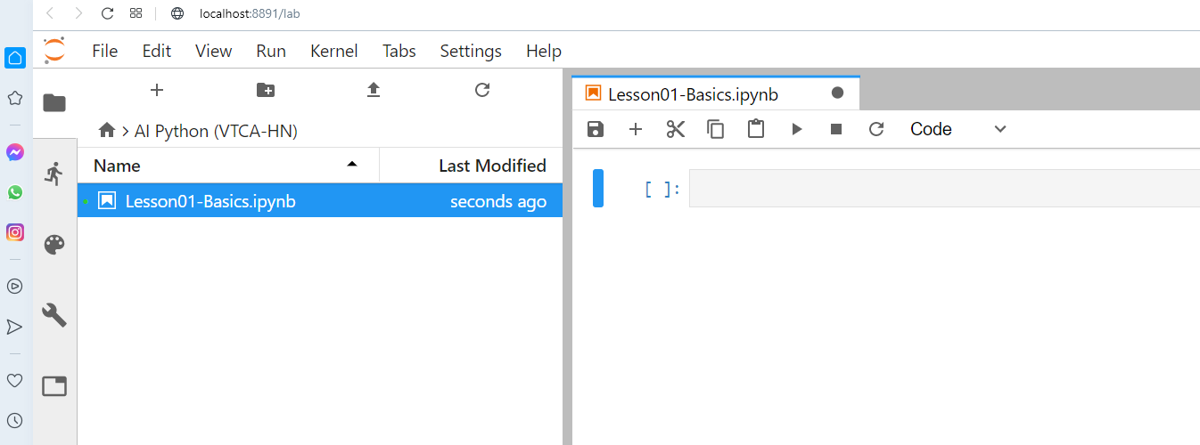

Step 5: Copy code below and run:

# Comment: Sample Code

x = 10

welcome = "Hello Python"

print(welcome)

print("Wish you get the good mark ", x)

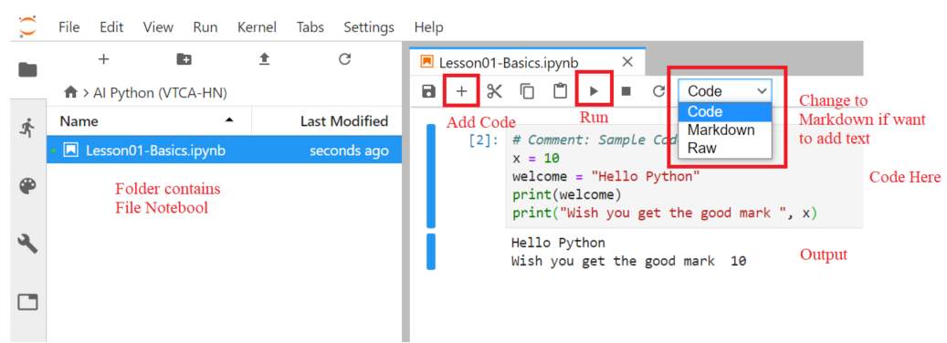

Step 6 : Copy Data into a Folder

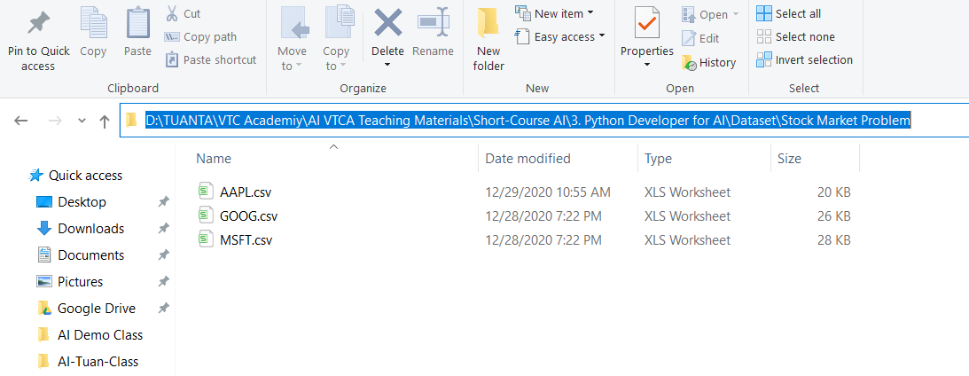

Step 7 : Run code to check Path and File Correct

# Check the path and file before reading them

import os

path_Data = **"…<<Your Correct Data Path>>…"**

checkPath = os.path.isdir(path_Data)

print("The path is valid or not :", checkPath)

checkFileApple = os.path.isfile(path_Data + "AAPL.csv")

checkFileGoogle = os.path.isfile(path_Data + "GOOG.csv")

checkFileMicrosoft = os.path.isfile(path_Data + "MSFT.csv")

print("The file is valid or not :", checkFileApple, checkFileGoogle, checkFileMicrosoft)

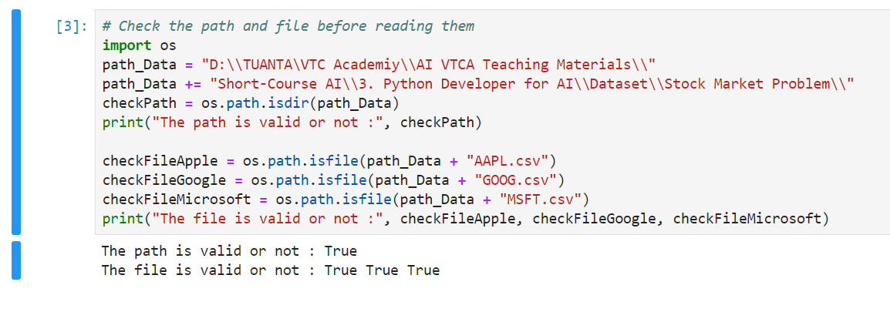

1. **Mark evaluation:**

|  |  |
| --- | --- |
| **Exercises** | **Mark**  **(100 Mark)** |
| **Exercise 1** | **50** |
| **Exercise 2** | **50** |

1. **Appendix: Sample Code**

**Colab:**

# Comment: Sample Code

x = 10

welcome = "Hello Python"

print(welcome)

print("Wish you get the good mark ", x)

# Mount drive

from google.colab import drive

drive.mount('/content/gdrive')

# Check the path and file before reading them

import os

path_Data = "//content//gdrive//MyDrive//AI Python (VTCA-HN)//Practice//Stock Market Problem//"

checkPath = os.path.isdir(path_Data)

print("The path is valid or not :", checkPath)

checkFileApple = os.path.isfile(path_Data + "AAPL.csv")

checkFileGoogle = os.path.isfile(path_Data + "GOOG.csv")

checkFileMicrosoft = os.path.isfile(path_Data + "MSFT.csv")

print("The file is valid or not :", checkFileApple, checkFileGoogle, checkFileMicrosoft)

**Anaconda:**

# Comment: Sample Code

x = 10

welcome = "Hello Python"

print(welcome)

print("Wish you get the good mark ", x)

# Check the path and file before reading them

import os

path_Data = "D:\\TUANTA\VTC Academiy\\AI VTCA Teaching Materials\\"

path_Data += "Short-Course AI\\3. Python Developer for AI\\Dataset\\Stock Market Problem\\"

checkPath = os.path.isdir(path_Data)

print("The path is valid or not :", checkPath)

checkFileApple = os.path.isfile(path_Data + "AAPL.csv")

checkFileGoogle = os.path.isfile(path_Data + "GOOG.csv")

checkFileMicrosoft = os.path.isfile(path_Data + "MSFT.csv")

print("The file is valid or not :", checkFileApple, checkFileGoogle, checkFileMicrosoft)